**Experiment 9**

**(By Aman Tyagi)**

**Aim: Running multiple services using Docker Swarm**

1) Creating manager and worker node

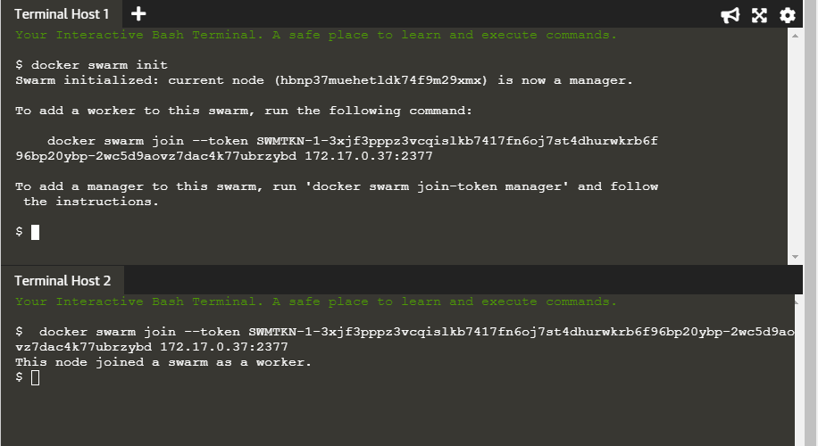

2) Creating the network

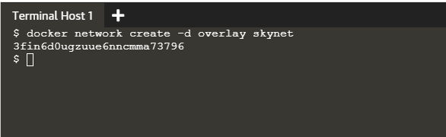

3) Deploying the service and running docker service ls

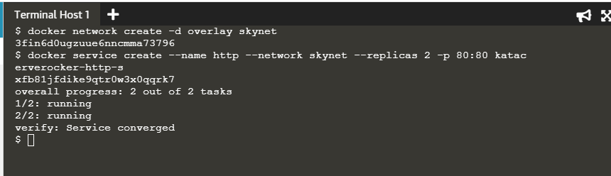

4) Running docker ps on both the terminal

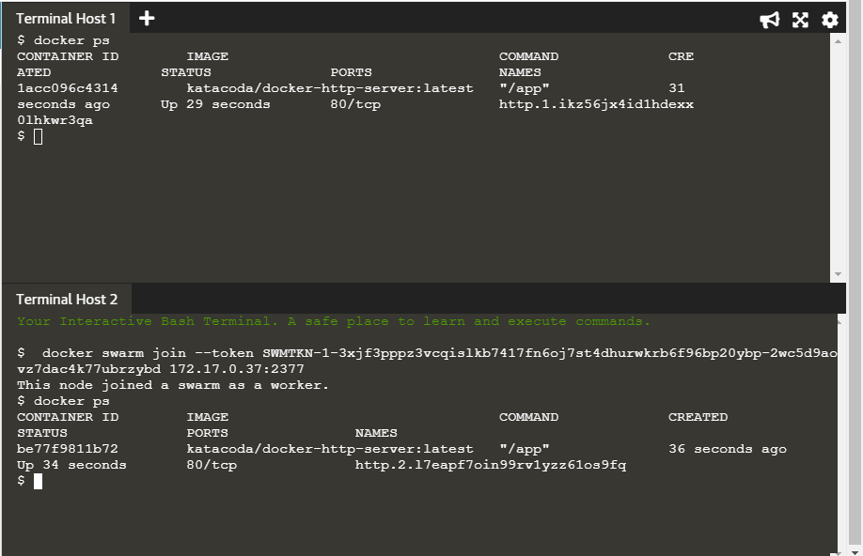

5) Running docker service ps http

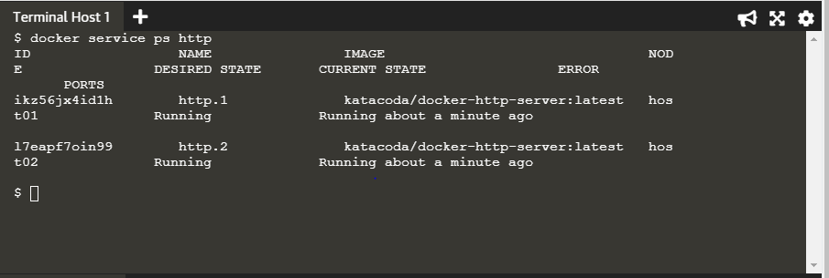

6) Running docker service inspect

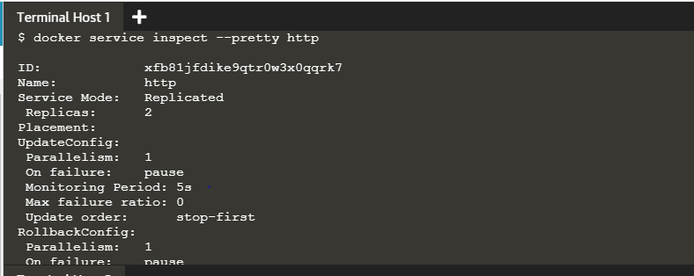

7) Scaling up

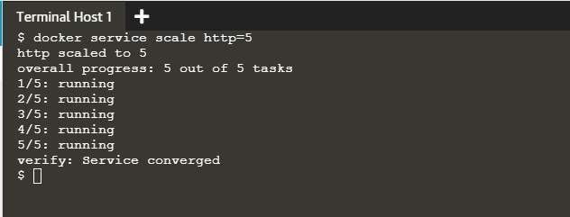

8) Checking with docker ps on both the terminal

